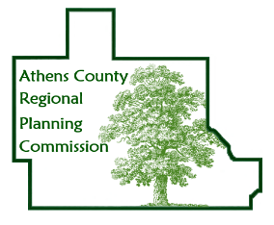Athens County Regional Planning Commission

AGENDA
for meeting at
ACEMS Station #51, 21 Kenny Drive, Athens, OH 45701

Thursday, April 11, 2024 8:00 AM

- Call to Order & Determination of Quorum

- Approval of Minutes

- Guests Present
- Swearing in of those wishing to speak
- Public Comments

- Announcements & Updates
- Officer Nominations

- New Business
- Updating Subdivision Regulations

- Continuing Discussions
- City/County Sewer Expansion Project
- Athens County Land Bank
- Broadband Expansion and Access
- Age Friendly Athens County
- SR 682 Corridor
- Appalachian Community Grants

- Planner Updates

- Organizational Updates

- Good of the Order

- Adjournment

Next meeting date: May 9, 2024

