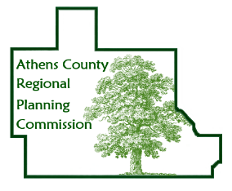Athens County Regional Planning Commission

AGENDA
for meeting at
ACEMS Station #51, 21 Kenny Drive, Athens, OH 45701

Thursday, October 12, 2023 8:00 AM

- Call to Order & Determination of Quorum

- Approval of Minutes

- Guests Present
- Swearing in of those wishing to speak
- Public Comments

- Announcements & Updates

- New Business

- Old Business

- Continuing Discussions
- City/County Sewer Expansion Project
- Athens County Land Bank
- Broadband Expansion and Access
- Age Friendly Athens County
- SR 682 Corridor
- Appalachian Community Grants

- Planner’s Report

- City, Village, Township and Organizational Reports

- Good of the Order

- Adjournment
Next meeting date: November 9, 2023

